Cajun Chicken Pasta Recipe

Ingredients
1 box penne pasta
1 lb chicken breasts
2 cups heavy cream
4 tsp cajun spice, divided
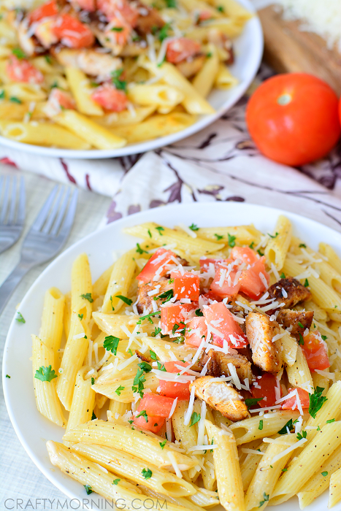
3 tbsp olive oil, divided
½ cup parmesan cheese
½ cup diced tomatoes
Directions
- Boil pasta according to package directions then drain and reserve for later
- While pasta is boiling, combine chicken breast, 2 tbsp olive oil and 2 tbsp cajun spice in a ziploc bag and marinade for at least 30 minutes.
- Add remaining olive oil to a skillet and cook chicken in skillet over medium- high heat for 7-8 minutes (or until internal temperature reaches 175 degrees)
- Remove chicken from skillet, cut in cubes and set aside.
- Combine cooked noodles, heavy cream, 2 tsp Cajun spice and parmesan cheese in the skillet
- Cook over medium-high heat stirring constantly until sauce has thickened
- Place cooked chicken on top of pasta and top with tomatoes and parmesan cheese
- Serve immediately

Cajun Spice Mix

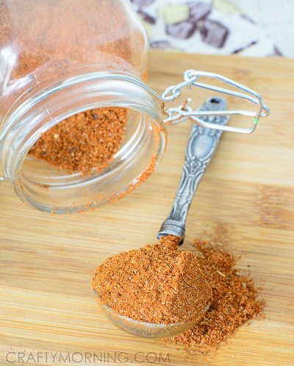
Ingredients
1½ Tbsp sea salt
2 Tbsp garlic powder
2 Tbsp paprika
1 Tbsp freshly ground black pepper
1 Tbsp cayenne
1 Tbsp onion powder
1 Tbsp dried oregano
1 tsp red pepper flakes
Directions
Combine all ingredients in a jar and mix well.

